Defect Report for Monfey
Defect ID:  (Required) | 001
Author:  (Required) | Mahmoud Omar
Release/Build #  (Required) | 1.9.8
Open Date:  (Required) | 11/6/2019
Close Date:  (Required) | NA
Problem Area:  (Required) | Checking UI
Defect or Enhancement:  (Required) | ♦ Defect (Default)  Enhancement
Problem Title:  (Required) | Account Name is not deleted from title area
Problem Description:  (Required) | Account Name is not deleted from title area if the account was selected before clearing data.  Video attached with the steps
Network: | Connected over wifi
Environment: | Android 9.0.17
Defect Type:  (Required) | Functionality (Default)  Architectural  Connectivity  Consistency  Database Integrity  Documentation  ♦ GUI  Installation  Memory  Performance  Security and Controls  Standards and Conventions  Stress  Usability
Reproducible Steps:  (Required) | 1. From the main menu choose an account with a unique name  2. open the control menu  3. click on settings  4. scroll down and select clear data  5. click yes  6. check the account name under the monefy title as it still exist
Priority:  (Required) | High (Default)  Critical  Medium  ♦ Low
Severity:  (Required) | High (Default)  Critical  Medium  ♦ Low
Status:  (Required) | ♦ Open  Being Reviewed by Development  Returned by Development  Ready for Testing in the Next Build  Closed (QA)  Returned by (QA)  Deferred to the Next Release
Affected Devices: | OnePlus 6T  Android Devices
Impact: | UI
Attachments: | https://drive.google.com/open?id=16MGjUGyXvgF75f8mPEJy7JJRbIS548Ts

Defect ID:  (Required) | 002
Author:  (Required) | Mahmoud Omar
Release/Build #  (Required) | Build where issue was discovered
Open Date:  (Required) | 11/6/2019
Close Date:  (Required) | NA
Problem Area:  (Required) | Check UI
Defect or Enhancement:  (Required) | ♦ Defect (Default)  Enhancement
Problem Title:  (Required) | in the tutorial the massage box is not alligned right
Problem Description:  (Required) | The instruction massage for the category icon is not aligned with the icon area.
Network: | Connected over wifi
Environment: | Android 9.0.17
Defect Type:  (Required) | Functionality (Default)  Architectural  Connectivity  Consistency  Database Integrity  Documentation  ♦ GUI  Installation  Memory  Performance  Security and Controls  Standards and Conventions  Stress  Usability
Reproducible Steps:  (Required) | 1. install the application  2. follow the instructions  3. check the massage box placement
Priority:  (Required) | High (Default)  Critical  Medium  ♦ Low
Severity:  (Required) | High (Default)  Critical  Medium  ♦ Low
Status:  (Required) | ♦ Open  Being Reviewed by Development  Returned by Development  Ready for Testing in the Next Build  Closed (QA)  Returned by (QA)  Deferred to the Next Release
Affected Devices: | OnePlus 6T  Android Devices
Impact: | minor
Attachments: | 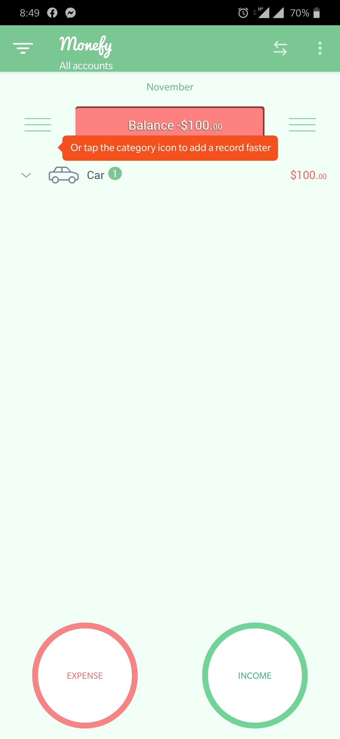

Defect ID:  (Required) | 003
Author:  (Required) | Mahmoud Omar
Release/Build #  (Required) | 1.9.8
Open Date:  (Required) | 11/6/2019
Close Date:  (Required) | NA
Problem Area:  (Required) | Balance menu
Defect or Enhancement:  (Required) | ♦ Defect (Default)  Enhancement
Problem Title:  (Required) | Initial balance does not appear or calculated on the day, week, month views in the balance page
Problem Description:  (Required) | Initial balance does not appear or calculated on the day, week, month views in the balance page only on the all time frame, video attached with the defect.
Network: | WIFI connected
Environment: | Android 9.0.17
Defect Type:  (Required) | ♦ Functionality  Architectural  Connectivity  Consistency  Database Integrity  Documentation  GUI  Installation  Memory  Performance  Security and Controls  Standards and Conventions  Stress  Usability
Reproducible Steps:  (Required) | 1.Create account with initial balance with today’s date  2. make sure the include initial balance is selected  3. open the account and check the initial balance in the balance page  4. change the view to today  5.check the balance menu  6. check the view to week  7. check the menu
Priority:  (Required) | ♦ High  Critical  Medium  Low
Severity:  (Required) | ♦ High  Critical  Medium  Low
Status:  (Required) | ♦ Open  Being Reviewed by Development  Returned by Development  Ready for Testing in the Next Build  Closed (QA)  Returned by (QA)  Deferred to the Next Release
Affected Devices: | OnePlus 6T  Android Devices
Impact: | High impact as the initial balance amount is not calculated or appear on all the day week and month views that will confuse the user.
Attachments: | https://drive.google.com/open?id=16n-sivvjnESuRbNl3l2DSOPEo1JQgHI7

Defect ID:  (Required) | 004
Author:  (Required) | Mahmoud Omar
Release/Build #  (Required) | 1.9.8
Open Date:  (Required) | 11/6/2019
Close Date:  (Required) | NA
Problem Area:  (Required) | Application warnings
Defect or Enhancement:  (Required) | Defect (Default)  ♦ Enhancement
Problem Title:  (Required) | Changing the currency in settings does not change the value of money recorded
Problem Description:  (Required) | Changing the currency in settings does not change the value of money recorded or display a warning that it does not.
Network: | Connected to wifi
Environment: | Android 9.0.17
Defect Type:  (Required) | ♦ Functionality (Default)  Architectural  Connectivity  Consistency  Database Integrity  Documentation  GUI  Installation  Memory  Performance  Security and Controls  Standards and Conventions  Stress  Usability
Reproducible Steps:  (Required) | 1. add an expense as the application is set up in USD  2. go to settings change the currency to be set on your local currency  3. go to the balance and check the amount you added as an expense  4. value is the same without a warning massage
Priority:  (Required) | High (Default)  Critical  ♦ Medium  Low
Severity:  (Required) | High (Default)  Critical  ♦ Medium  Low
Status:  (Required) | ♦ Open  Being Reviewed by Development  Returned by Development  Ready for Testing in the Next Build  Closed (QA)  Returned by (QA)  Deferred to the Next Release
Affected Devices: | OnePlus 6T  Android Devices
Impact: | User might change the currency and add the value expecting that the old values are converted.
Attachments: | https://drive.google.com/open?id=16yeTF0QFG_AD0WizDac0K80D_wIbByBG

Defect ID:  (Required) | 005
Author:  (Required) | Mahmoud Omar
Release/Build #  (Required) | 1.9.8
Open Date:  (Required) | 11/6/2019
Close Date:  (Required) | NA
Problem Area:  (Required) | Clear Data feature
Defect or Enhancement:  (Required) | ♦ Defect (Default)  Enhancement
Problem Title:  (Required) | Budget value is not cleared after clearing data
Problem Description:  (Required) | Budget value exists after clearing data using the clear data feature in settings.  Video attached
Network: | Android Version 9
Environment: | Android 9.0.17
Defect Type:  (Required) | ♦ Functionality (Default)  Architectural  Connectivity  Consistency  Database Integrity  Documentation  GUI  Installation  Memory  Performance  Security and Controls  Standards and Conventions  Stress  Usability
Reproducible Steps:  (Required) | 1. enable budget mode from the side panel  2. set the budget to a random value  3. clear data from the clear data button  4. check the budget in the UI
Priority:  (Required) | High (Default)  Critical  ♦ Medium  Low
Severity:  (Required) | High (Default)  Critical  ♦ Medium  Low
Status:  (Required) | ♦ Open  Being Reviewed by Development  Returned by Development  Ready for Testing in the Next Build  Closed (QA)  Returned by (QA)  Deferred to the Next Release
Affected Devices: | OnePlus 6T  Android Devices
Impact: | Budget need to be deleted manually
Attachments: | https://drive.google.com/open?id=16zV0cokIJK1Fg_LfwcYH0wRiOi2b017Y

Defect ID:  (Required) | 006
Author:  (Required) | Mahmoud Omar
Release/Build #  (Required) | 1.9.8
Open Date:  (Required) | 11/6/2019
Close Date:  (Required) | NA
Problem Area:  (Required) | Describe the problem area
Defect or Enhancement:  (Required) | ♦ Defect (Default)  Enhancement
Problem Title:  (Required) | lines are not drown even if the percentages are equal
Problem Description:  (Required) | lines are not drown even if the percentages are equal in the main panel icons that are far from the color are not connected, screenshot attached
Network: | Android Version 9
Environment: | Android 9.0.17
Defect Type:  (Required) | Functionality (Default)  Architectural  Connectivity  Consistency  Database Integrity  Documentation  ♦ GUI  Installation  Memory  Performance  Security and Controls  Standards and Conventions  Stress  Usability
Reproducible Steps:  (Required) | 1.add expenses to each category with the same value  2. check the lines
Priority:  (Required) | High (Default)  Critical  Medium  ♦ Low
Severity:  (Required) | High (Default)  Critical  Medium  Low
Status:  (Required) | ♦ Open  Being Reviewed by Development  Returned by Development  Ready for Testing in the Next Build  Closed (QA)  Returned by (QA)  Deferred to the Next Release
Affected Devices: | OnePlus 6T  Android Devices
Impact: | Visual
Attachments: | 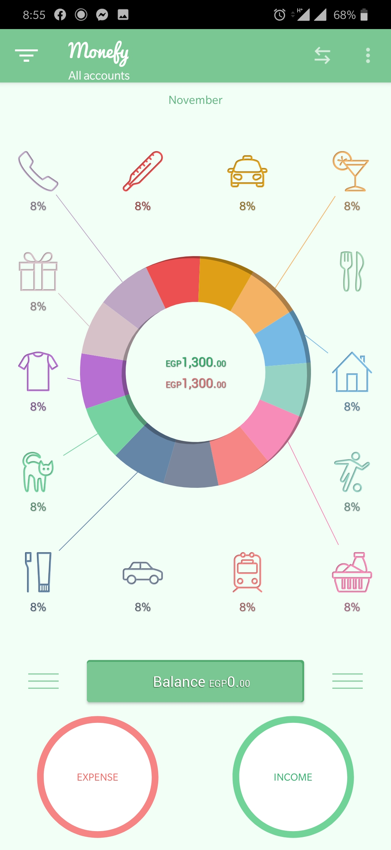

eNHANCMENTS

- deleting the last existing account must give the user a warning that they need at least one account to use the application.
- tracking transfers into a separate log or a history table
- instructions need to be improved with more details

